FOOD MANAGEMENT SYSTEM

**Use-Case Specification: Choosing Product**

Version <1.0>

Revision History

|  |  |  |  |
| --- | --- | --- | --- |
| **Date** | **Version** | **Description** | **Author** |
| <7/12/2020> | <1.0> | <details> | <Nguyen Thu Trang> |

Table of Contents

1. Use-Case Name 4

1.1 Brief Description 4

2. Flow of Events 4

2.1 Basic flow 4

2.2 Alternative flow 4

2.2.1 <First Alternative flow> 4

2.2.1 <Second Alternative flow> 4

3. Special Requirement 4

3.1 <First Special Requirement> 4

4. Preconditions 4

4.1 <Precondition One> 4

5. Posstcondition 4

5.1 <Postcondition One> 5

6. Extension Points 5

6.1 < Name of Extension Points> 5

**Use-Case Specification: Choosing Product**

1. **Choosing product**
   1. **Brief Description**

This use case defines the step of choosing products. The system allow customer to choose product in the product view.

* 1. **Actor**

Customer

1. **Flow of Events**
   1. **Basic Flow**

First, customer click on View of product button. The system display product view. Customer will click on Select button on the product details new product need to be order. Customer click on Save to confirm change. After, system will update product information on product selected view

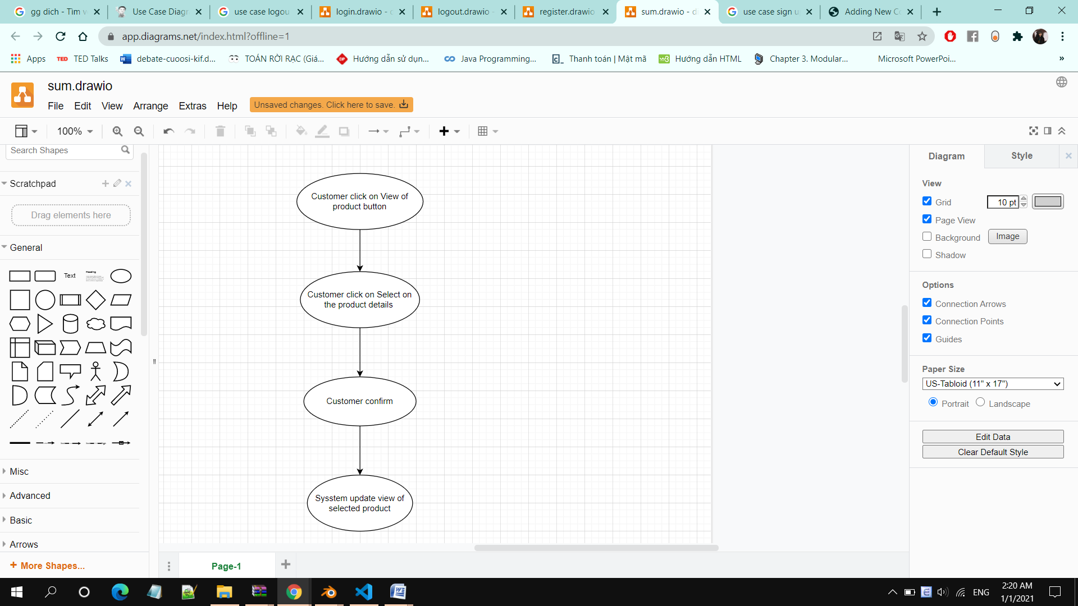

1. **Special Requirements**

Customer must know how to use the product management system.

1. **Preconditions**

Customer has account and login successful

1. **Postconditions**

No postconditions.

1. **Extension Points**

No extension points.